Sri Lanka Institute of Information

Technology



Lab Submission Lab Sheet 05

**IT24101387** **Deshani B.A.M**

**Probability and Statistics | IT2120**

B.Sc. (Hons) in Information Technology

**Exercise**

1. **Import the dataset (’Exercise – Lab 05.txt’) into R and store it in a data frame called ”Delivery Times”.**

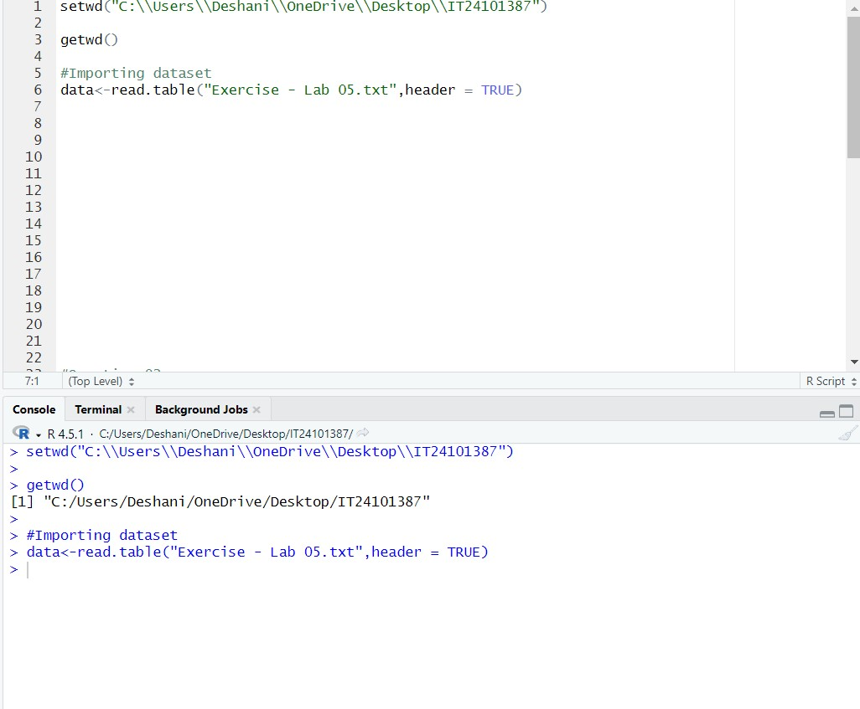

1. **Draw a histogram for deliver times using nine class intervals where the lower limit is 20 and upper limit is 70. Use right open intervals.**

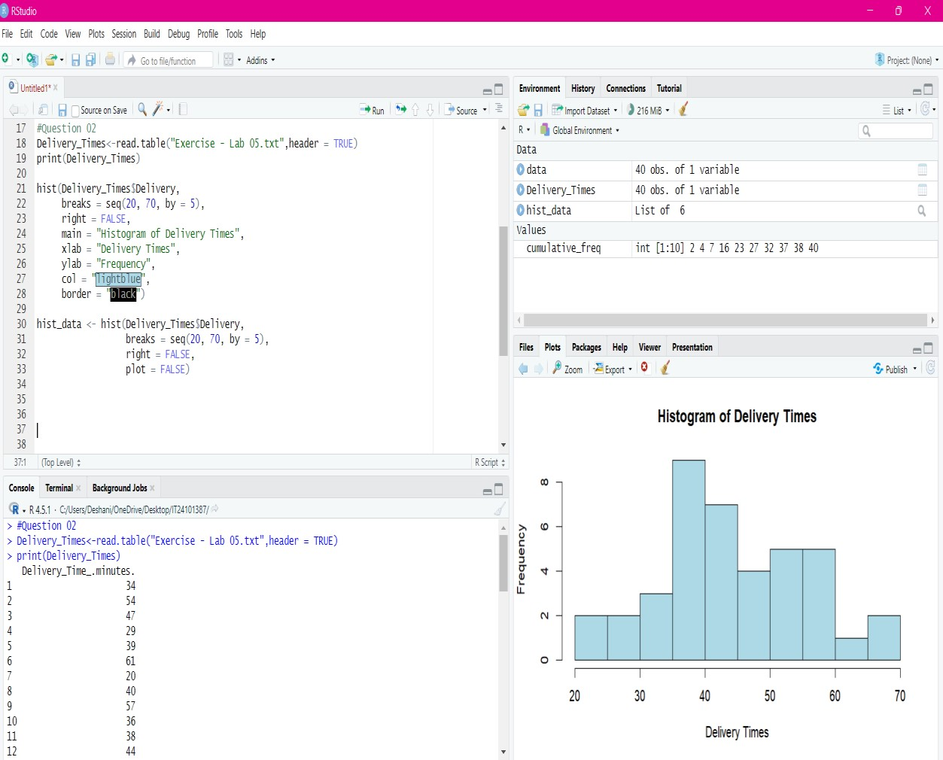

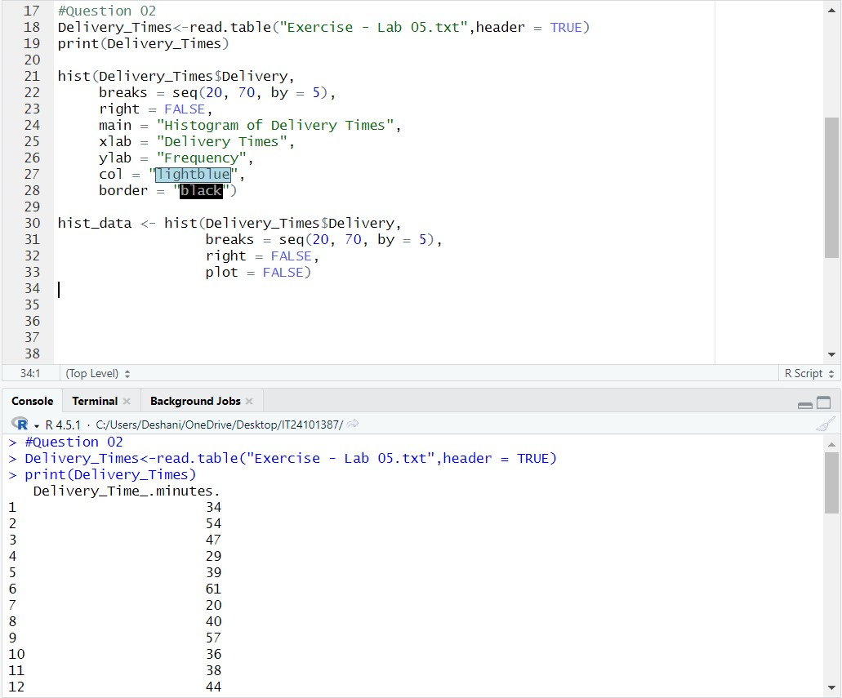

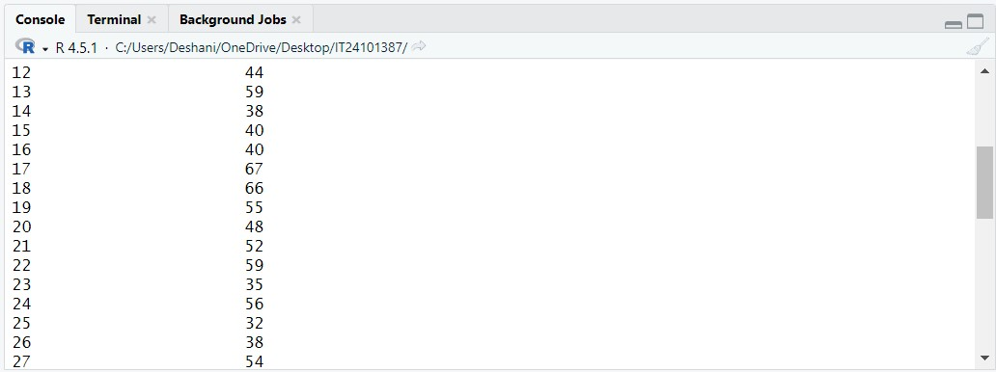

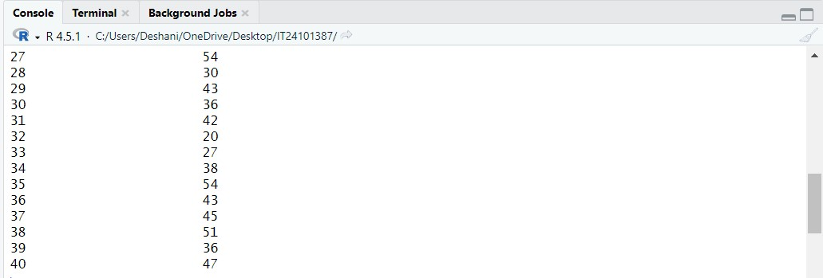

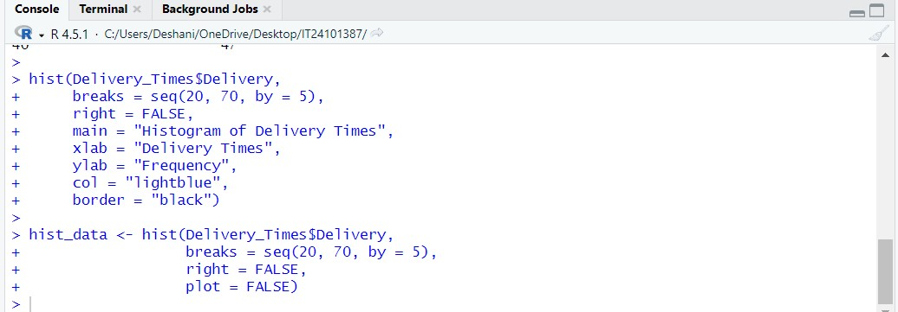

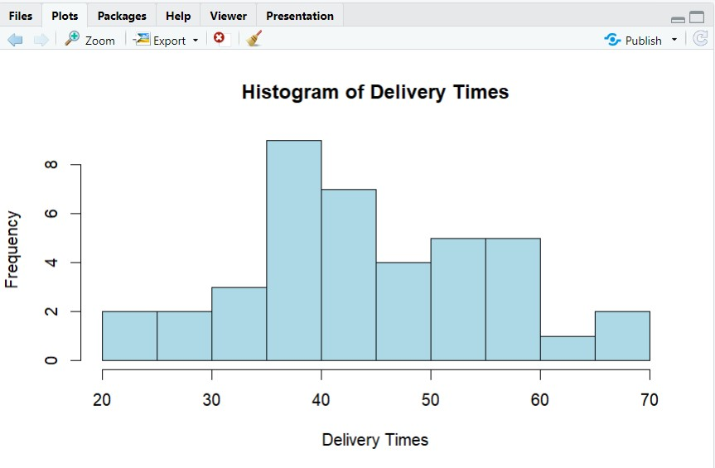

1. **Comment on the shape of the distribution.**



1. **Draw a cumulative frequency polygon (ogive) for the data in a separate plot.**

